Google Fusion

Navaneethan Rajasekaran

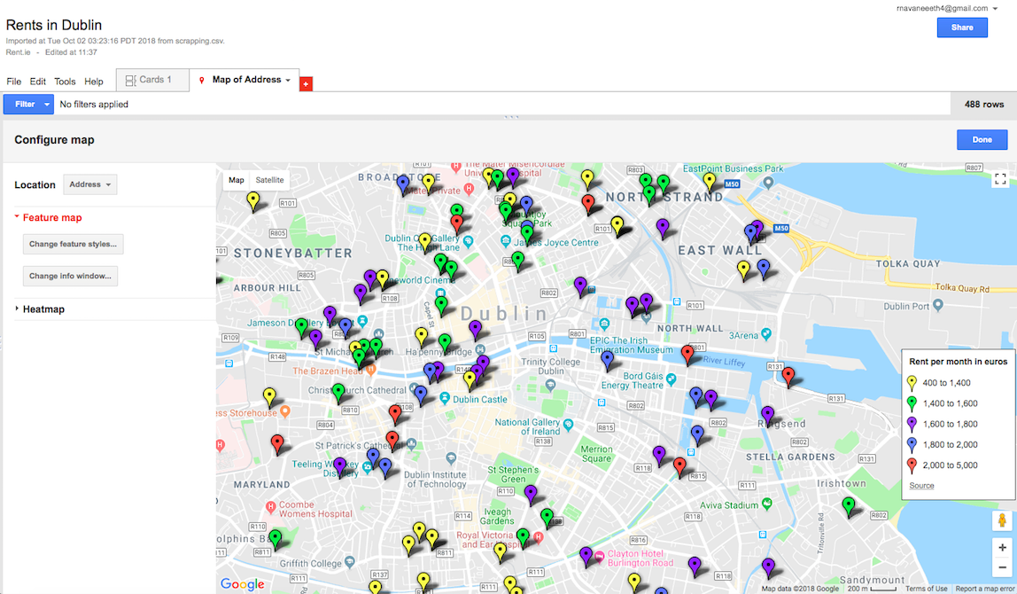

## Link : https://fusiontables.google.com/data?docid=1Dem41etuPTX51eSJPg8oIIx7Ko1rKX-m_ToYLnev#map:id=3

## Source: Rents.ie

Language: Python

Library: BeautifulSoup